EXPT NO:8 | FORECASTING AND PREDICTIVE ANALYTICS USING TABLEAU AND POWER BI
DATE: 14.08.2026

PRE-LAB QUESTIONS (PROVIDE BRIEF ANSWERS TO THE FOLLOWING QUESTIONS)

NAME: ABHISHEK J

ROLL NO.: 24BAD002

What is forecasting in the context of Business Intelligence (BI)?
Forecasting in Business Intelligence (BI) is the process of using historical and current data to predict future trends, values, or outcomes. It helps organizations estimate future sales, demand, revenue, expenses, and business performance. BI tools such as Tableau and Power BI use statistical techniques and historical patterns to generate forecasts. Forecasting supports better decision-making, resource planning, budgeting, inventory management, and strategic business planning.

Explain the difference between predictive analytics and descriptive analytics.

Descriptive Analytics | Predictive Analytics
Focuses on understanding what has already happened using historical data. | Focuses on predicting what is likely to happen in the future.
Uses reports, dashboards, charts, and KPIs. | Uses statistical techniques, forecasting models, and machine learning.
Example: Analyzing previous monthly sales. | Example: Predicting next month's sales based on previous trends.
Helps understand past business performance. | Helps organizations make future-oriented decisions and plans.

Name two common forecasting methods used in Tableau and Power BI.
Two common forecasting methods used in Tableau and Power BI are time-series forecasting and exponential smoothing. Time-series forecasting analyzes historical observations over time to identify trends, patterns, and seasonality. Exponential smoothing gives greater importance to recent observations while forecasting future values. Tableau commonly provides forecasting through built-in exponential smoothing models, while Power BI provides forecasting features and supports statistical or machine-learning approaches depending on the visualization and implementation.

Why is data granularity important for accurate forecasting?
Data granularity refers to the level of detail at which data is stored and analyzed, such as daily, weekly, monthly, or yearly records. Appropriate granularity is important because forecasting models depend on identifying meaningful trends and seasonal patterns. Very detailed data may contain unnecessary fluctuations or noise, while overly aggregated data may hide important patterns. Choosing the correct granularity improves forecast accuracy and makes business trends easier to interpret.

Name two challenges in forecasting using multiple data sources.
Two major challenges are data inconsistency and data integration. Data inconsistency occurs when different sources use different formats, naming conventions, units, or data types, which can lead to inaccurate forecasts. Data integration becomes challenging when datasets have different structures, time periods, levels of granularity, or missing values. Proper data cleaning, transformation, matching common fields, and establishing correct relationships between datasets are necessary to ensure reliable forecasting results.

IN-LAB EXERCISE:
OBJECTIVE:
To perform time series forecasting and predictive analytics on historical sales data using Tableau and Power BI, and visualize future trends for informed decision-making.

PROCEDURE:

Data Collection:
  - Import historical sales data from multiple sources:
    - Dataset 1: Sales Data (CSV) → Order ID, Order Date, Region, Sales Amount
    - Dataset 2: Promotions Data (Excel) → Promotion ID, Region, Promotion Start Date, Promotion End Date, Discount

Data Preparation and Transformation:
  - Clean data: standardize date formats, remove duplicates, handle missing values.
  - Aggregate sales data at the required granularity (daily, weekly, or monthly).
  - Ensure numeric fields (Sales, Discount) are correct.

Data Integration and Modeling:
  - Tableau: Connect datasets and relate them using the Region field.
  - Power BI: Create relationships in the Model view; define cardinality where necessary.

Forecasting and Predictive Analytics:
  - Tableau:
    - Use the Forecast feature on Sales over time. o Apply trend models like Exponential Smoothing and visualize prediction intervals.

Power BI:
    - Use built-in forecasting in line charts. o Optionally, create a DAX measure for predicted sales using moving averages or linear regression.

Create Calculated Fields:
  - Forecasted Sales = Predicted value from the model
  - Sales Growth % = ((Forecasted Sales – Actual Sales) / Actual Sales) * 100

Design a Comprehensive Dashboard:
  - Line chart showing actual vs. forecasted sales over time.
  - KPI cards: Total Forecasted Sales, Expected Growth %.
  - Use combo charts to show sales trends along with promotion periods.
  - Highlight regions with expected growth above or below target thresholds.

Validate Forecast Accuracy:
  - Compare forecasts against actual historical sales (back-testing).
  - Adjust forecasting parameters if necessary (e.g., seasonality length, smoothing factor).

Publishing and Sharing:
  - Tableau: Publish workbook to Tableau Public or Tableau Server.
  - Power BI: Publish report to Power BI Service and share with stakeholders.

Experiment Datasets:
  - Dataset 1: Historical Sales Data (CSV) → Order ID, Order Date, Region, Sales
  - Dataset 2: Promotions Data (Excel) → Promotion ID, Region, Promotion Start/End Date, Discount
Tableau
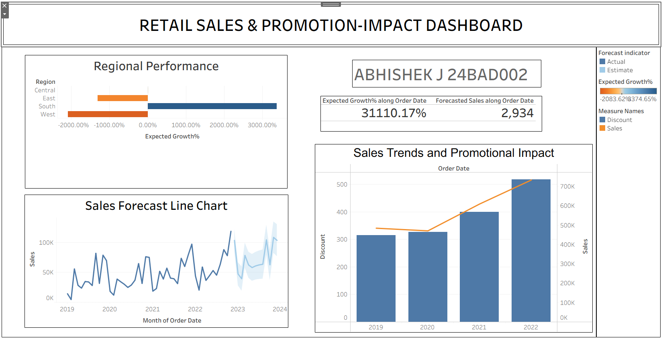

Power BI
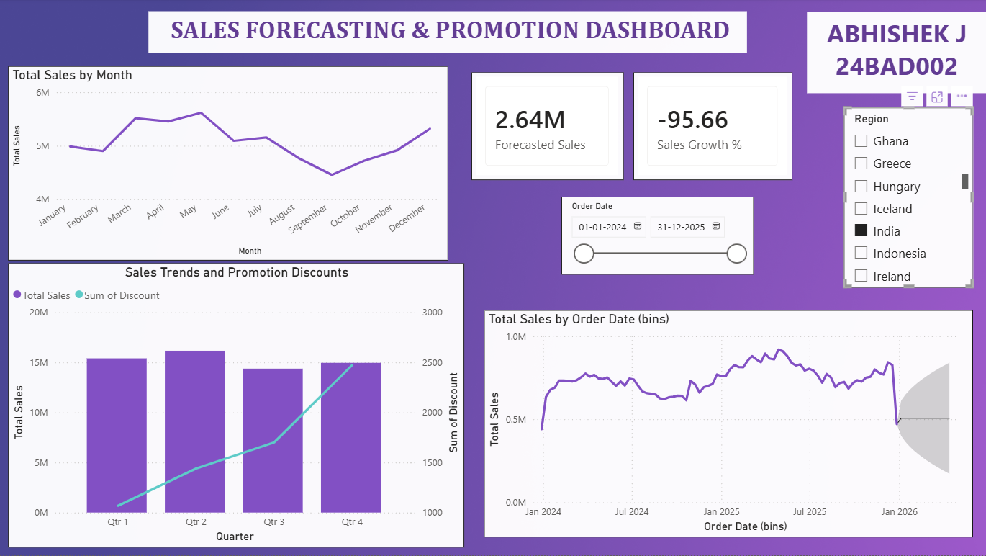

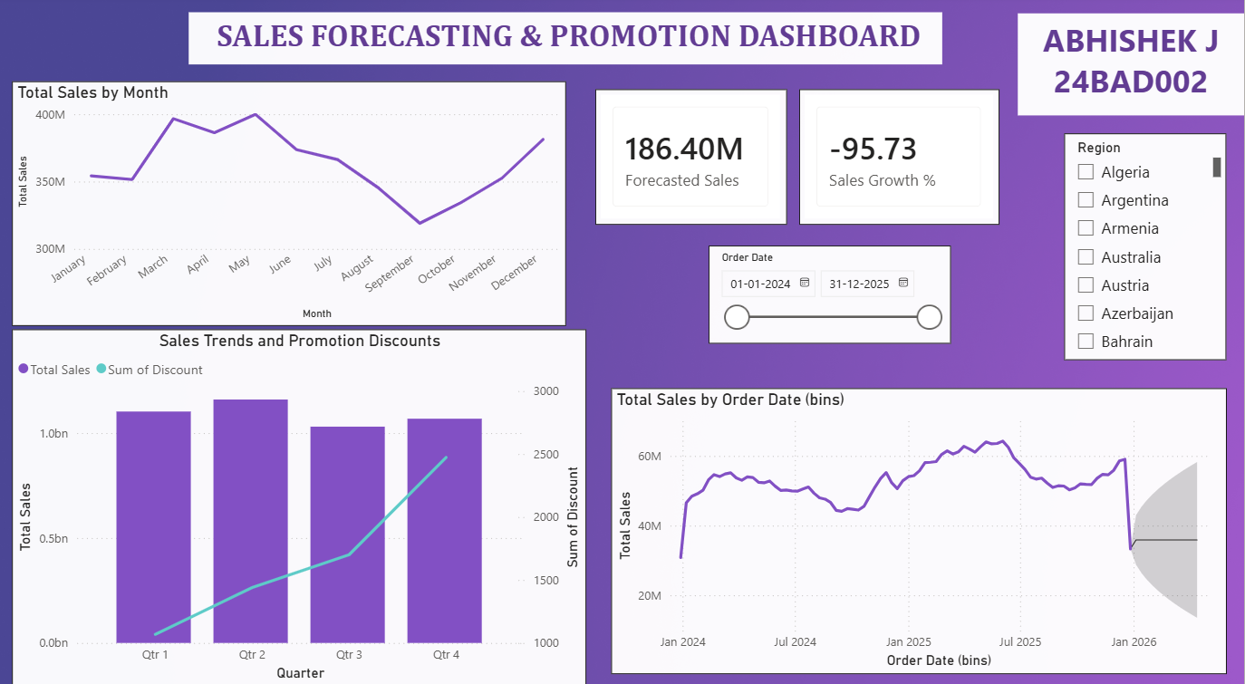

POST-LAB QUESTIONS (PROVIDE BRIEF ANSWERS TO THE FOLLOWING QUESTIONS)

How did forecasting help in predicting future sales trends for business planning?
Forecasting helped predict future sales trends by analysing historical sales patterns and identifying changes over time. The forecast provided an estimate of expected future sales, allowing the business to plan inventory, staffing, budgets, and marketing activities more effectively. It also helped identify potential increases or decreases in demand. By using these predictions, management can make informed decisions, reduce uncertainty, and prepare suitable strategies for future business conditions.

What forecasting method did you use, and why was it suitable for the dataset?
The forecasting method used was time-series forecasting with exponential smoothing. It was suitable because the dataset contained sales values associated with specific order dates over multiple years. Exponential smoothing considers historical patterns while giving more importance to recent observations. This makes it useful for identifying sales trends and generating future estimates. The method is also commonly supported by BI tools such as Tableau, making it practical for business forecasting.

What challenges, if any, did you face regarding missing data or irregular time intervals?
One challenge was ensuring that the sales data had consistent and correctly formatted dates. Missing values or irregular time intervals can affect the identification of trends and seasonal patterns. In the prepared dataset, the data was cleaned and the date field was converted into the correct date format. This allowed Tableau to analyze the sales information chronologically.
Proper data preparation helped reduce inconsistencies and improved the reliability of the forecasting results.

How can predictive analytics influence decision-making in a retail environment?
Predictive analytics can help retailers make better decisions by estimating future customer demand, sales, inventory requirements, and purchasing patterns. It can identify products that are likely to perform well and highlight periods of increased or decreased demand. Retailers can
use these insights to optimize inventory, plan promotions, adjust pricing, and allocate resources. This reduces the risk of overstocking or stock shortages while improving customer satisfaction and overall profitability.

What additional data could be integrated to improve forecast accuracy?
Additional data such as competitor pricing, customer demographics, promotional campaigns, economic indicators, seasonal events, weather conditions, and online customer behaviour could improve forecast accuracy. Competitor pricing can reveal market pressure, while promotional data can explain sudden changes in sales. Economic indicators can provide information about purchasing power and market conditions. Integrating these external factors with historical sales data can help forecasting models understand more variables that influence retail demand.
GitHub Link: https://github.com/j-abhishek26/24ADC001-24BAD002/tree/main/Experiment%208

RESULT:
The historical sales and promotions datasets were successfully cleaned, integrated, and modeled in Tableau and Power BI. Forecasting techniques provided predicted sales trends, growth percentages, and region-wise performance expectations. The resulting dashboards allowed managers to visualize actual vs. forecasted sales, enabling better planning and datadriven decision-making.

ASSESSMENT

Description | Max Marks | Marks Awarded
Pre Lab Exercise | 5
In Lab Exercise | 10
Post Lab Exercise | 5
Viva | 10
Total | 30
Faculty Signature

